Obsessive Compulsive Disorder



**We all double or triple check something on occasion. We forget if we’ve locked the door or wonder if we’ve left the water running, and we want to be certain. Some of us are perfectionists, so we go over our work several times to make sure it’s right. That’s not abnormal behavior. But if you have obsessive-compulsive disorder (OCD), you feel compelled to act out certain rituals repeatedly, even if you don’t want to — and even if it complicates your life unnecessarily.**

**Obsessions are the worrisome thoughts that cause anxiety. Compulsions are the behaviors you use to relieve that anxiety.**

**Signs and Symptoms of OCD**

**Signs of OCD usually become apparent in childhood or early adulthood. It tends to begin slowly and become more intense as you mature. For many people, symptoms come and go, but it’s usually a lifelong problem. In severe cases, it has a profound impact on quality of life. Without treatment, it can become quite disabling.**

**Some common obsessions associated with OCD include**

* **anxiety about germs and dirt, or fear of contamination**
* **need for symmetry and order**
* **concern that your thoughts or compulsions will harm others, feeling you can keep other people safe by performing certain rituals**
* **worry about discarding things of little or no value**
* **disturbing thoughts or images about yourself or others**



**Some of the behaviors that stem from these obsessive thoughts include**

* **excessive hand washing, repetitive showering, unnecessary household cleaning**
* **continually arranging and reordering things to get them just right**
* **checking the same things over and over even though you know you’ve already checked them**
* **hoarding unnecessary material possessions like old newspapers and used wrapping paper rather than throwing them away**
* **counting or repeating a particular word or phrase. Performing a ritual like having to touch something a certain number of times or take a particular number of steps**
* **focusing on positive thoughts to combat the bad thoughts**

**Social Signs: What to Look For?**

**Some people with OCD manage to mask their behaviors so they’re less obvious. For others, social situations trigger compulsions. Some things you might notice in a person with OCD:**

* **raw hands from too much hand washing**
* **fear of shaking hands or touching things in public**
* **avoidance of certain situations that trigger obsessive thoughts**
* **intense anxiety when things are not orderly or symmetrical**
* **need to check the same things over and over**
* **constant need for reassurance**
* **inability to break routine**
* **counting for no reason or repeating the same word, phrase, or action**
* **at least an hour each day is spent on unwanted thoughts or rituals**
* **having trouble getting to work on time or keeping to a schedule due to rituals**

**Since OCD often begins in childhood, teachers may be the first to notice signs in school. A child who is compelled to count, for instance, may not be able to complete the ritual. The stress can cause angry outbursts and other misbehaviors. One who is afraid of germs may be fearful of playing with other children. A child with OCD may fear they are crazy. Obsessions and compulsions can interfere with schoolwork and lead to poor academic performance.**

**Children with OCD may have trouble expressing themselves. They may be inflexible and upset when plans change. Their discomfort in social situations can make it difficult to make friends and maintain friendships. In an attempt to mask their compulsions, children with OCD may withdraw socially. Isolation increases the risk for depression.**

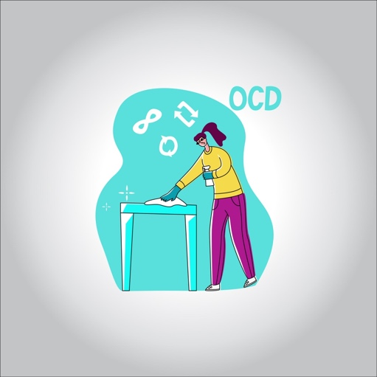

**Risk Factors and Complications**

**The cause of OCD is not known. It seems to run in families, but there may be environmental factors involved. Most of the time, symptoms of OCD occur before age 25.**

**If you have OCD, you’re also at increased risk of other anxiety disorders, including major depression and social phobias.**

**Just because you like things a certain way or arrange your spice rack in alphabetical order, it doesn’t mean you have OCD. However, if obsessive thoughts or ritualistic behavior feels out of your control or are interfering with your life, it’s time to seek treatment.**

**Treatment usually involves psychotherapy, behavioral modification therapy, or psychiatric medications, alone or in combination. According to Harvard Medical School, with treatment, approximately 10 percent of patients fully recover and about half of patients show some improvement.**